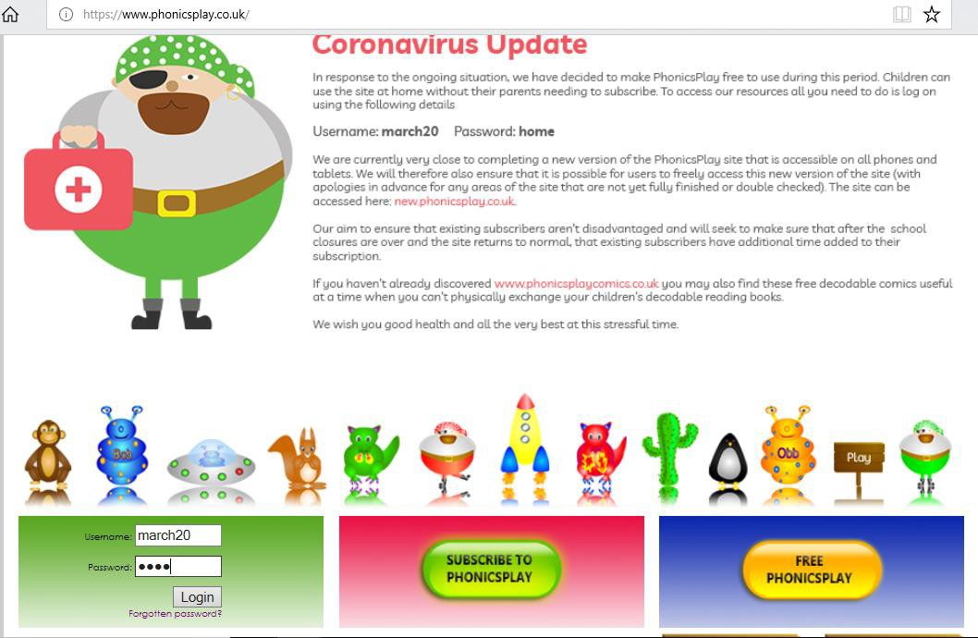Phonics Play Instructions –www.phonicsplay.co.uk

Type in the username: march20 and the password: home and click login

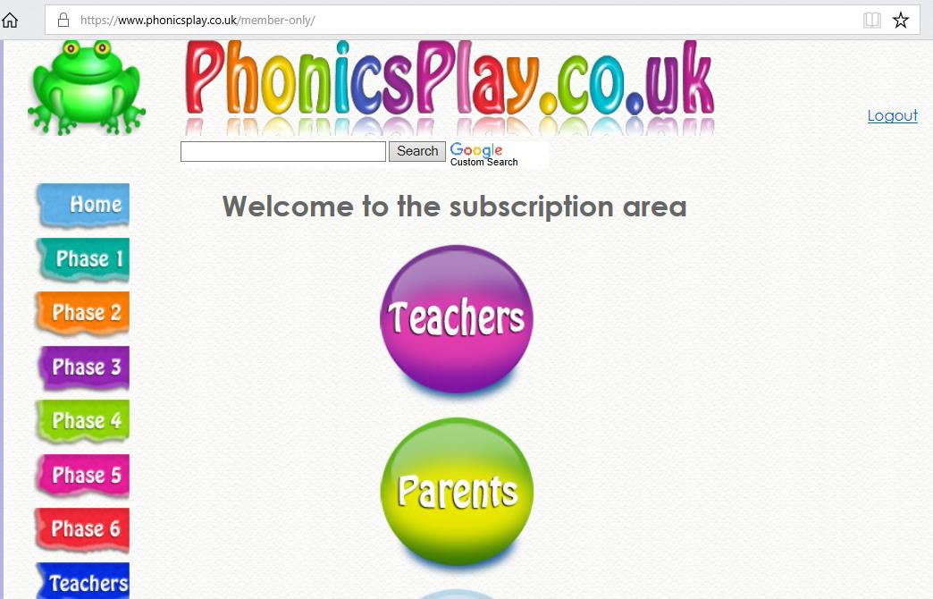

You will come to this page. If you would like to learn more about phonics click on ‘parents’ and explore the options there. If you would like to go straight to the games and activities for your child click on ‘phase 2’ or ‘phase 3’

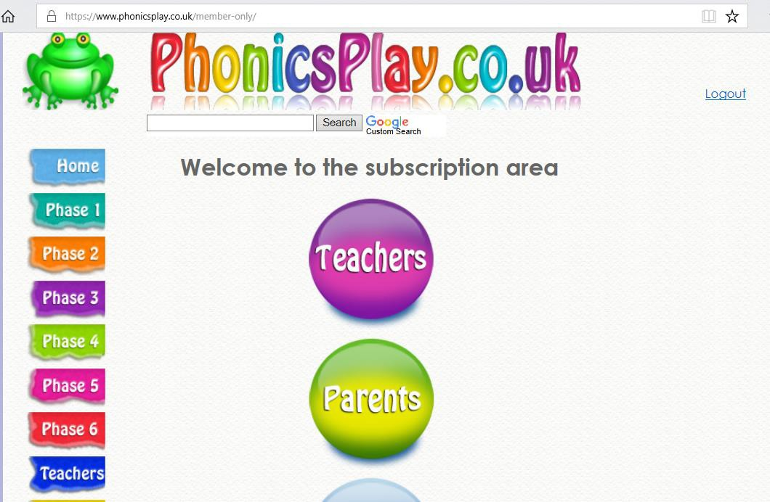

You will then be shown a range of games as below:
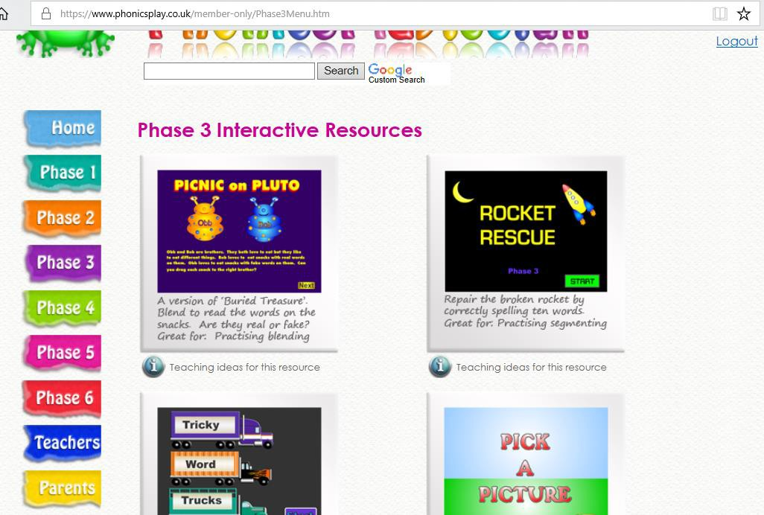
Choose a game you would like. I will show you ‘Picnic on Pluto’ as an example.

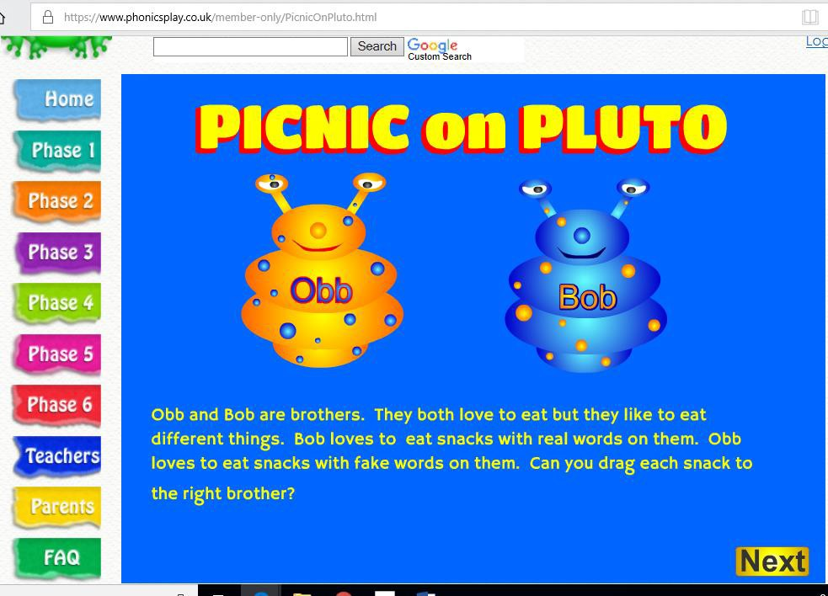Click next and follow the instructions on the following page.

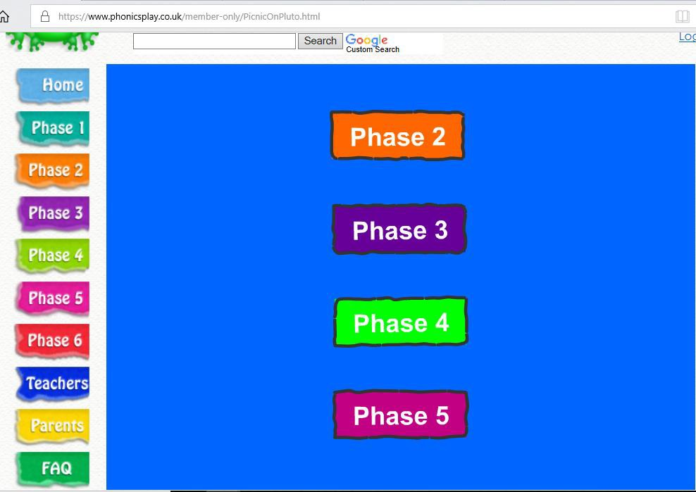

Choose ‘phase 2’ or ‘phase 3’.
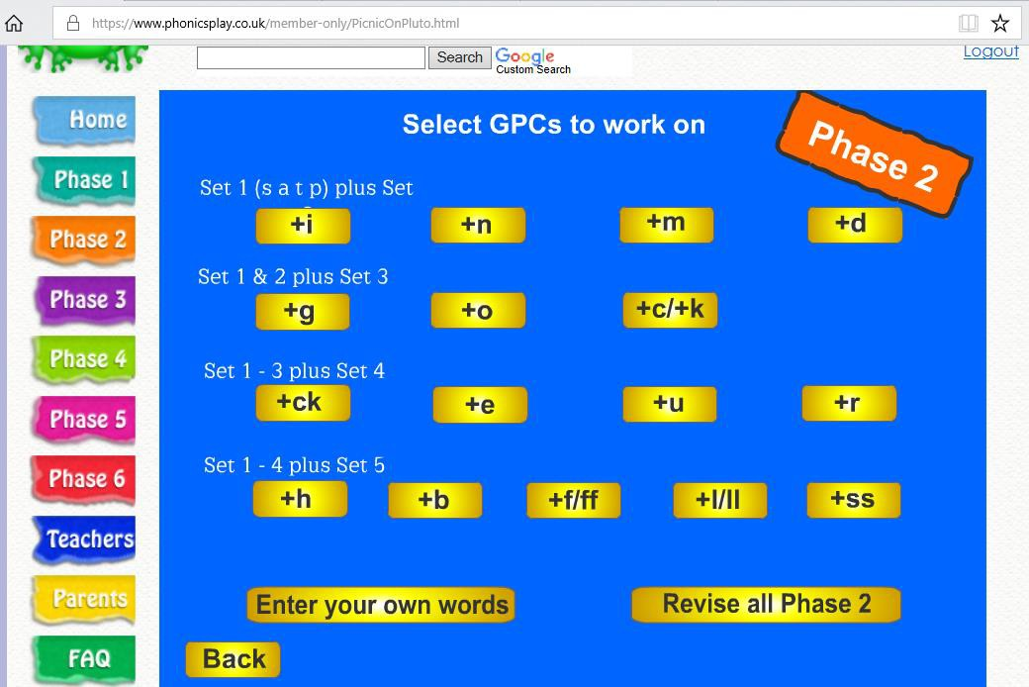

Once you have selected which phase you want you will need to choose with sounds to work on, for example, if you click on +g it will have words with s,a,t, p, i, n, m, d and g in them.

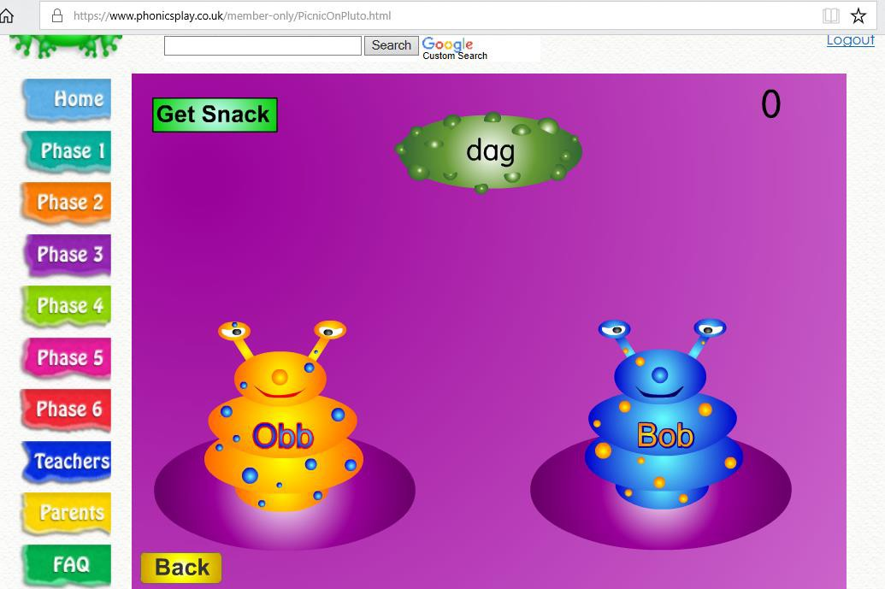

Your child can then play the game!
Some of the ones we regularly play in class are:
- Buried Treasure
- Picnic on Pluto
- Flashcards Time Challenge
- Tricky Word Trucks

If you’re not sure what phase or set to start your child on, it’s better to start on phase 2 set 1 and work your way up to all of phase 3.

