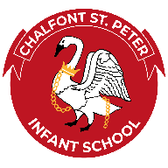Cultural Capital Life Experiences
At Chalfont St Peter Infant School, we promise every child that by the time they leave us at the end of Year 2 they will have been offered a variety of enrichment opportunities to develop a thirst for learning. They will have the opportunity to:
Go on a School Trip.  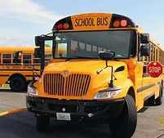 | Hold a position of responsibility  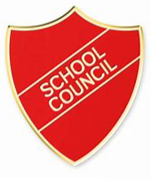 | Enjoy a sports Day.  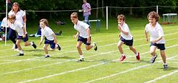 | Be the worker of the week.   | Raise money for charity.  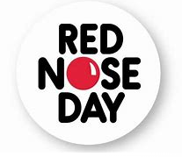 | Have a go at cooking.   | Celebrate Arts Week.   | Attend a concert.   | Take part in a performance.  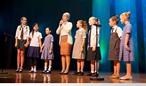 | Perform a song with your class.  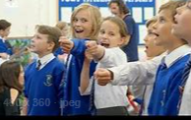
Explore other religions festivals in other cultures.  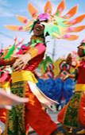 | Celebrate Saints days.  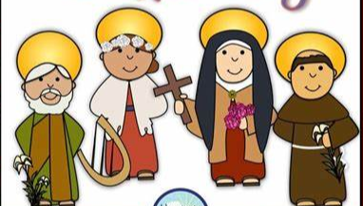 | Enjoy a live performance.  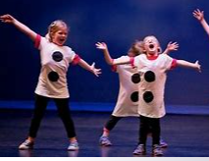 | Join a School club.  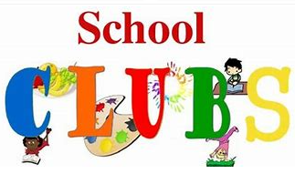 | Find out about online safety.   | Sell something they have made.   | Have subject WOW Days.   | Go to see a pantomime.  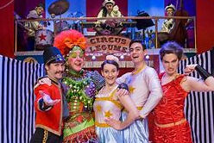 | Learn about road Safety.   | Enjoy a visit from the local police.  
Do the daily mile.   | Learn another language.   | Have many enrichment activities.  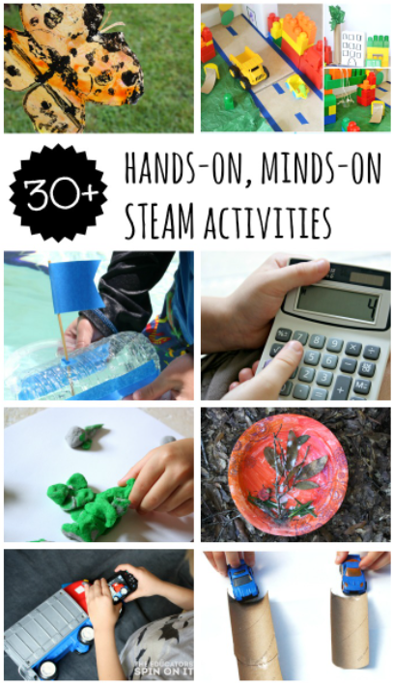 | Have a go at public speaking.   | Learn maypole dancing.  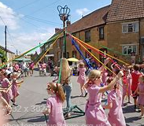 | Take part in World Book day.   | Write a poem.  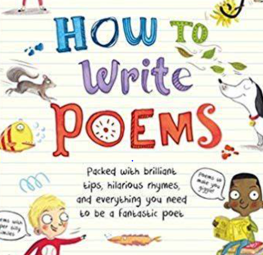 | To support the Food bank CSG.   | Learn outdoors in all weathers.  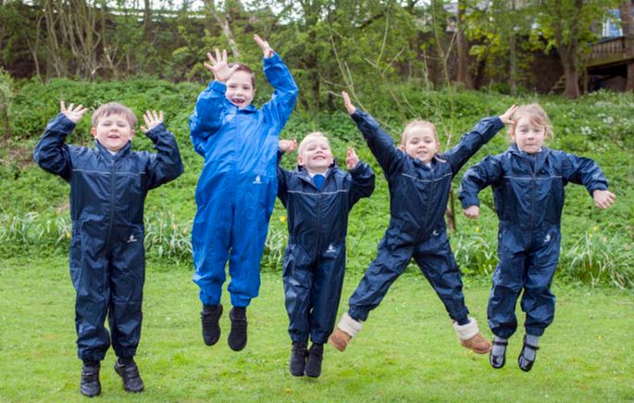 | Understand and care for environment.  
Cultural Capital at our School and beyond.

