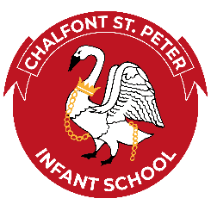Cultural Capital at Chalfont St Peter Infant School 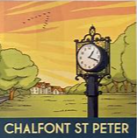
At Chalfont St Peter Infant School, we encourage every child to fully appreciate and participate in all aspects of life. In order to provide experiences and develop skills we have created a selection of activities to inspire young minds and help them enjoy life to the fullness within our community.
Feast Day  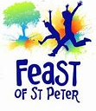 | Visit Open Air museum  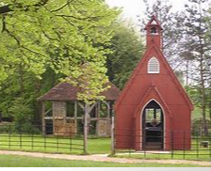 | Sing in public  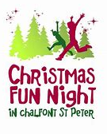 | Fly a kite/Roll down gold hill  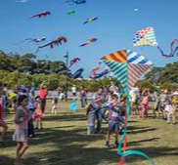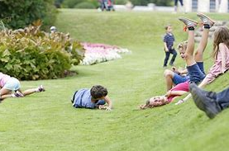 | Find out who Roald Dahl is.  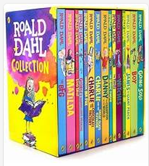 | Find out who John Milton is ?  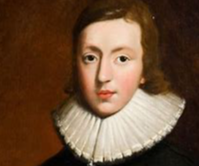 | Eat fish and chips   | Visit the local church  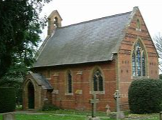 | Learn about the beacon.   | Create glass in Fired works  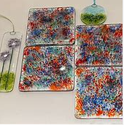
Walk through bluebells in the wood  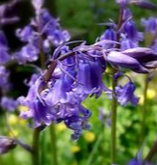 | Learn about London   | Eat a sundae in Looking Glace/cafe   | Attend remembrance parade  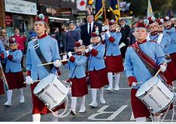 | Where was James Bond filmed?  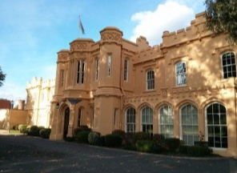 | Find out who Capability Brown is  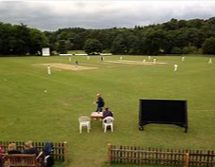 | Do the heritage walk  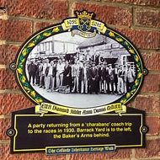 | Visit the Heritage Clock  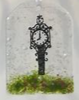 | 1066 Doomsday Book village  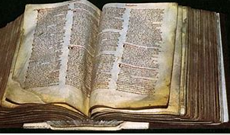 | Go for a swim visit the leisure centre  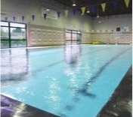
Litter pick and dip in the misbourne  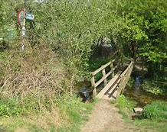 | Visit the monument  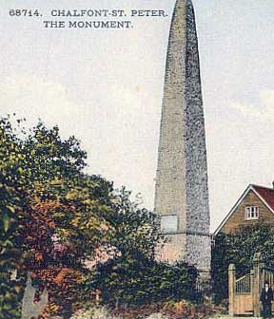 | Farm visit  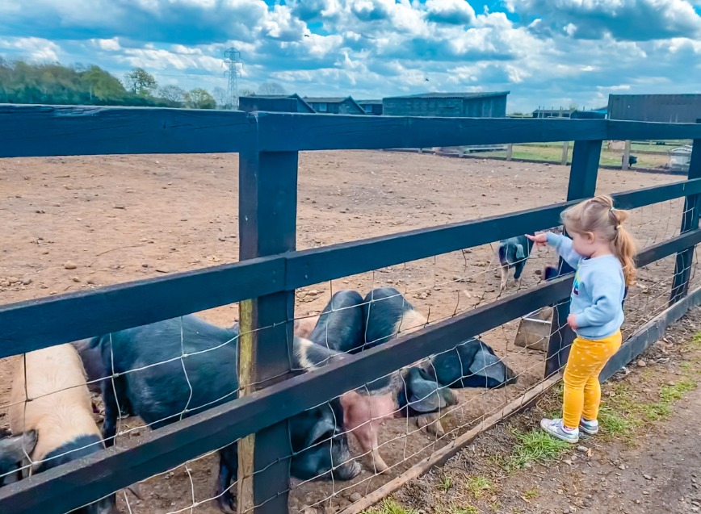 | Litter pick to help your community stay clean  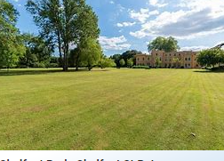 | Sledge down Gold hill  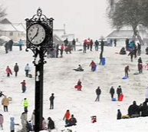 | Paint pottery be creative   | Pond dipping in pond lane  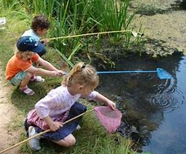 | Shop for fruit, veg, cakes and treats locally  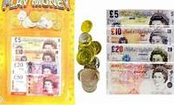 | Read a book in the library  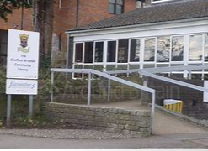 | Wander through the allotments  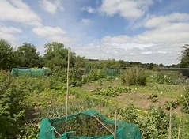
Cultural Capital in our Community

