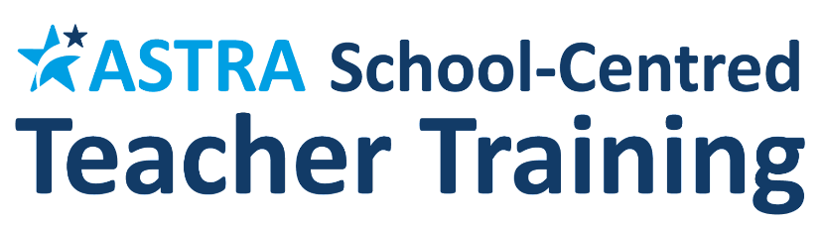

Chalfont St Peter Infant School is proud to be in partnership with the Astra School Centred Initial Teacher Training (SCITT) provider, an innovative, Ofsted Outstanding and non-profit organisation which provides outstanding training opportunities for new entrants into the teaching profession.The Astra SCITT is part of the Astra Teaching School Hub, accredited by the DfE as one of only 87 Hubs in the country to offer the 'golden thread' of training and support for teachers at all stages of their career.
Astra is currently recruiting Primary and Secondary trainees in the following subjects/phases across over 50 local selective, non-selective, primary and special schools for 2023-4: Art; Biology; Business; Economics with Business; Chemistry; Computer Science; Drama; English; Geography; History; Maths; Modern Foreign Languages; Music; PE; Physics; RE; Primary; Primary with Maths. Some part time routes are also available.
More information can be found on the DfE train to teach portal, as well as the Astra website, and applications can be made via DfE Apply.
You may be eligible for a generous bursary to train!
If you have active Social Media accounts, it would be great if you could follow Astra. Our social media handles are as follows:

Twitter @astra_hub
Instagram astratsh
LinkedIn Astra Teaching School Hub & SCITT
Facebook @AstraHub
Many thanks for your support



