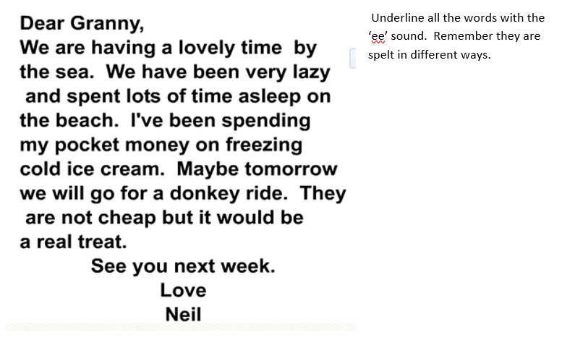
https://www.phonicsplay.co.uk/resources/phase/5/alt-spellings-ee Click on the link to play Phonics Play for ‘ee’

